

Agentic AI & Sports Intelligence
Subtitle
Diogo Domingues Godinho

Master Thesis
presented as partial requirement for obtaining a Master’s Degree in Information Management

NOVA Information Management School
Instituto Superior de Estatística e Gestão de Informação
Universidade Nova de Lisboa

NOVA Information Management School
Instituto Superior de Estatística e Gestão de Informação
Universidade Nova de Lisboa

TITLE
Subtitle

by
Diogo Domingues Godinho

Master Thesis presented as partial requirement for obtaining the Master’s degree in Information Management, with a specialization in ………

Supervised by
Supervisor’s name, academic title (PhD; MSc…), Academic institution or School affiliation of the supervisor
EXAMPLE: Miguel de Castro Neto, PhD, NOVA Information Management School

Month, Year

Statement of Integrity
I hereby declare having conducted this academic work with integrity. I confirm that I have not used plagiarism, any form of undue use of information or falsification of results along the process leading to its elaboration. I further declare that I have fully acknowledged the Rules of Conduct and Code of Honor from the NOVA Information Management School.
[place, date]
Just type your name, not your signature

Dedication (OPTIONAL)

Just if you want to dedicate your work to someone dear to you or to someone that inspired you in your life. Here is not the place for acknowledge, it is a distinct honour to someone, although it is optional.

Acknowledgements (OPTIONAL)

This is an optional page, however it is always very important to acknowledge those who made this possible, like family, friends, colleagues, professors, staff, University, and those who anonymously participated in the data collection phase, for example.

Abstract
This work presents an innovative approach to injury forecasting, performance projection, and athlete evaluation in sports (particularly the NFL) by integrating Agentic Artificial Intelligence, Generative Artificial Intelligence, and blockchain technology. The objective is to develop a system capable of processing historical and real-time data to deliver accurate, accessible, and scalable insights, particularly for teams with limited resources. The methodology combines three main datasets: historical yearly player statistics, weekly performance data from the 2020 season, and daily biometric metrics from a former player, including heart rate, sleep patterns, and fatigue. The proposed system employs Agentic AI to automate data collection, analysis, and cross-referencing, while Generative AI transforms results into natural-language reports tailored for coaches, analysts, and medical teams. Blockchain ensures the integrity, traceability, and transparency of athlete records, enabling the creation of an “Athlete Passport” consolidating attributes, performance history, and health information. Designed to operate continuously, the model stores data for longitudinal analysis and generates performance indices that support training load management, injury prevention, and performance optimization. By providing an automated and user-friendly workflow capable of generating alerts and objective comparisons, this research aims to demonstrate how integrating these technologies can enhance the efficiency, accuracy, and accessibility of sports analytics processes in professional and semi-professional contexts, paving the way for broader adoption of predictive analysis in daily team operations.

Keywords
Keyword 1; Keyword 2; Keyword 3; Keyword 4; Keyword 5 (always separated by ; )

Sustainable Development Goals (SDG):


Table of Contents
Statement of Integrity ii
Dedication (OPTIONAL) iii
Acknowledgements (OPTIONAL) iv
Abstract v
List of Figures viii
List of Tables ix
List of Abbreviations and Acronyms x
0. Formatting guidelines [DELETE THIS CHAPTER] xi
1. Introduction 1
2. Literature review 4
2.1. Sport Management 4
2.1.1. Concepts 4
2.1.2. Challenges and Opportunities 4
2.1.3. The use of intelligent technologies in Sport Management 4
2.2. Agentic AI 4
2.2.1. Overview 4
2.2.2. Approaches and Platforms 4
2.2.3. Agentic AI in Sports 5
2.3. Related Work 5
3. Methodology 6
4. Empirical Study 7
5. Results and Discussion 8
6. Conclusions and Future Research 9
Bibliographical References [This title should not be numbered] 10
Appendix A (optional, appendixes should have letters instead of numbers) 11
Annex A (optional) 12

List of Figures
Figure 0.1 – Illustrative figure xv

List of Tables
Table 0.1 – Illustrative table xv

List of Abbreviations and Acronyms
Acronym A Explanation of acronym A Explanation of acronym A Explanation of acronym A Explanation of acronym A Explanation of acronym A Explanation of acronym A
Acronym B Explanation of acronym B Explanation of acronym B Explanation of acronym B Explanation of acronym B Explanation of acronym B Explanation of acronym B

0. Formatting guidelines [DELETE THIS CHAPTER]
Your work must not contain chapter number 0. You must delete this chapter from the document of your final work.
This Word file provides a "standard" proposal structure and all the styles necessary for adequately formatting the Master Thesis/Work Project of NOVA Information Management School of Universidade Nova de Lisboa.
Students must use the APA style standard for bibliographical references; this standard also applies to the references format and respective referencing forms throughout the text.
In this file you will also find a step-by-step guide for formatting the text, figures and tables throughout your work. We advise you to always keep a copy of this template for future reference while you work on your thesis.

In case of other text format or bibliographic references doubts, contact the Library and Documentation Services for help.
- Pagination
For different styles of pagination, it’s necessary to add a Page Break before the page we want to add the pagination. For that, go to the Insert tab and select Page Break:
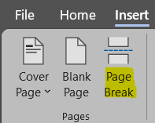
If the previous option creates a blank page, go to Insert tab and click with mouse’s right button on Pages to Customized the Ribbon:
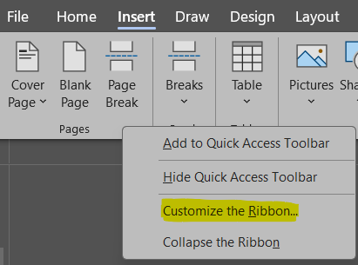
On the left side of the dialog box, select the option Insert Page & Section Breaks:
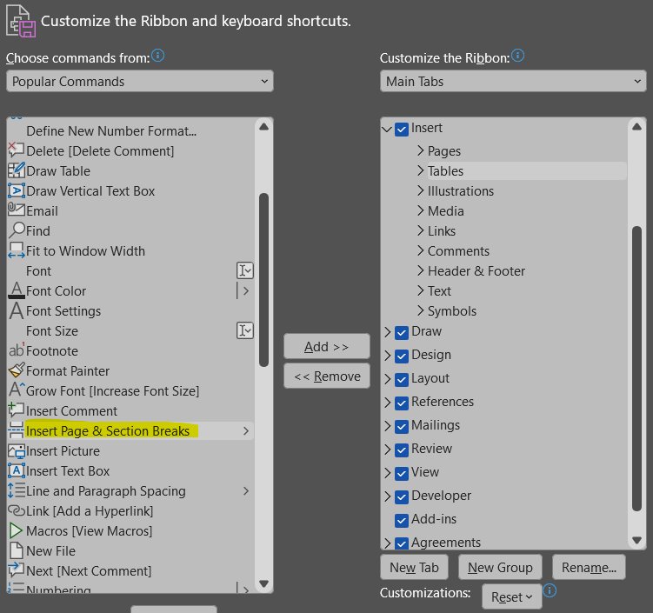
On the right side, select Pages and create a New Group (you may rename it as you wish; in this case, we called it Breaks). Then click Add:
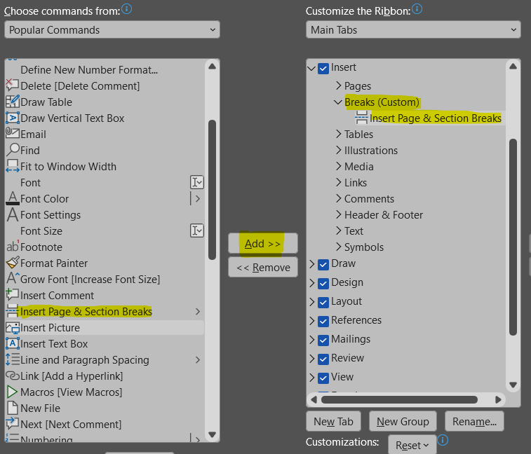
On the Insert Tab, you will find the new ribbon Breaks. Select the option Continuous to create a section break without adding a new blank page:
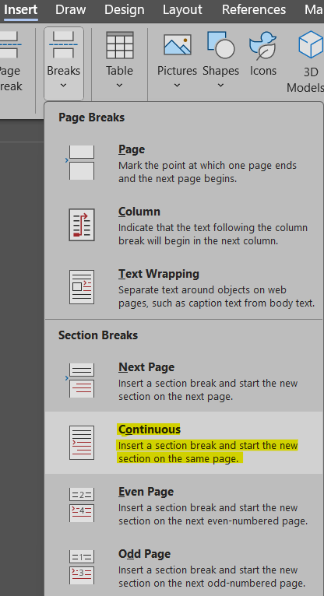
To insert the pagination, select the option Page Number, and choose Format Page Numbers:
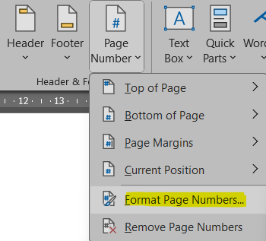

Select the Number format (i, ii, iii, … for the preliminary pages and 1, 2, 3, … for the body of the text):
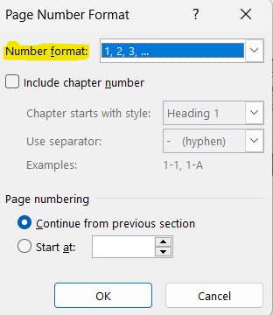

- Labels of figures and tables
To insert a figure label, go to the References tab and select the option Insert Caption:
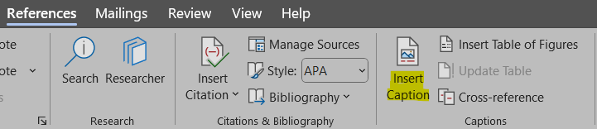
Select the option Numbering:
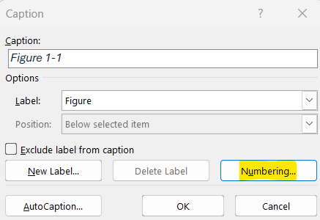
Choose Format 1, 2, 3, ... and select the box in the option Include chapter number (it is possible to select the Heading of each chapter and select a hyphen or a dot as separator between numbers):
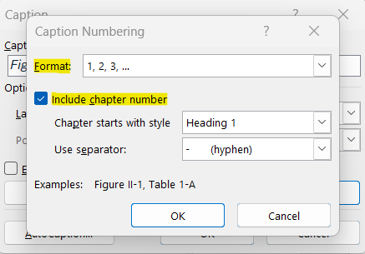

To insert a table label, go to the References tab and select the option Insert Caption:
In Label, select the option Table, then select Numbering:
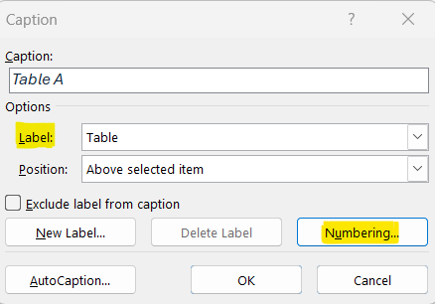
Choose Format 1, 2, 3, ... and select the box in the option Include chapter number (it is possible to select the Heading of each chapter and select a hyphen or a dot as separator between numbers):
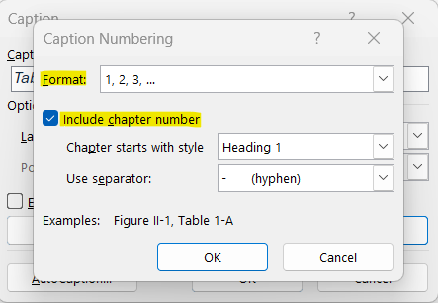

Here is an example of a figure label:

Figure 0.1 – Illustrative figure
Note that figure labels should be included after the figure. The alignment of the label should also be centered, instead of aligned to the left. Make sure the figure’s alignment is also centered, for a more cohesive layout throughout the work.
Here you can find an example of a table label:

Table 0.1 – Illustrative table
Title | Title
Text | Number
Text | Number
Text | Number

The student can freely choose the table design, as long as it remains consistent throughout the document. Note that table labels should always be included before the table. The alignment of both the table and the label should be centered throughout the work.
- List of Figures and List of Tables
To insert List of Figures, go the References tab and select the option Insert Table of Figures:
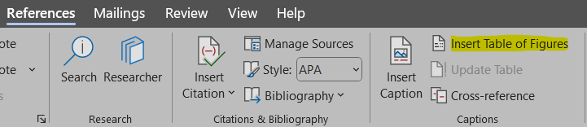
Verify that the Caption label selected is Figure:
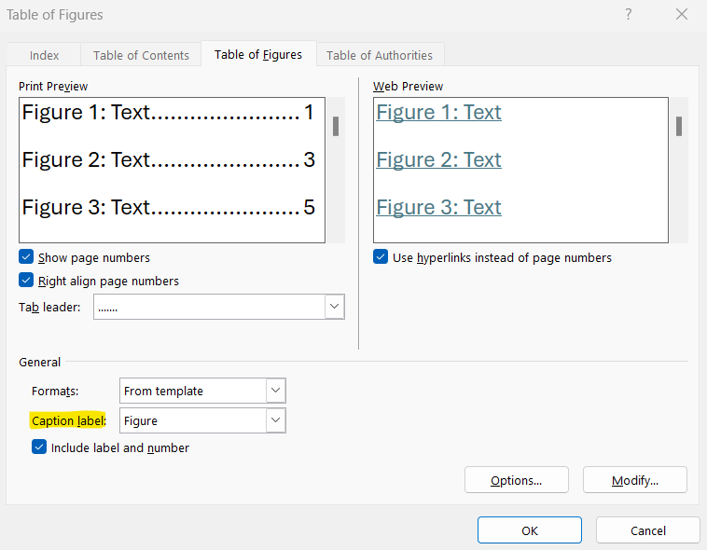

To insert List of Tables, go to the References tab and select the option Insert Table of Figures:

Verify that the Caption label selected is Table:
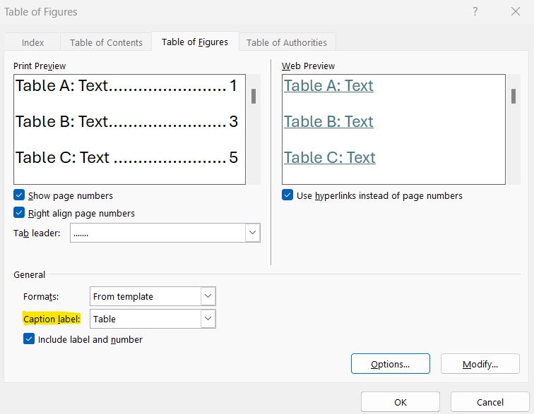
- Equations
We advise the identification of the equations present throughout the work to be done on the right:
${\left(x+a\right)}^{n}=\sum_{k=0}^{n}{\left({n \atop k}\right)x^{k}a^{n-k}}$ (0.1)

You can follow the chapter numeration, just like the figures and tables, or you can start with (1).
- Computer coding/Algorithms
For computing code, algorithms or other, it should appear with the label before the code framing, as the following example.
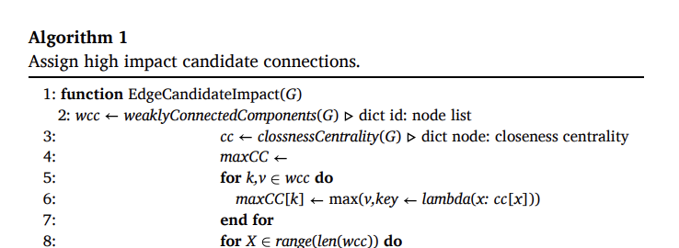
- Bibliographical references
Use APA Style for the entire document. Don’t forget to organize your bibliographical references alphabetically.
We suggest that students use a reference manager system (Zotero, Mendeley, EndNote).
Please review the APA style guide at: https://apastyle.apa.org/style-grammar-guidelines/references/examples
Example:
Author, A. A., Author, B. B., & Author, C. C. (Year). Title of article. Title of Periodical, volume number (issue number), pages. DOI or permanent link.

Here’s a references list with examples of different types of materials:

Areed, S., Alqaryouti, O., Siyam, B., & Shaalan, K. (2020). Aspect-Based Sentiment Analysis for Arabic Government Reviews. In Abd Elaziz, M., Al-qaness, M., Ewees, A., Dahou, A. (Eds.), Recent Advances in NLP: The Case of Arabic Language. Studies in Computational Intelligence (vol. 874, pp. 143–162). Springer. https://doi.org/10.1007/978-3-030-34614-0_8 [book chapter example]

Cook, J. (2024, June 21). Data To Decisions With ChatGPT: 5 Prompts To Analyze Business Metrics. Forbes. https://www.forbes.com/sites/jodiecook/2024/06/21/data-to-decisions-with-chatgpt-5-prompts-to-analyze-business-metrics/ [Website example]

Ercan, Ö., & Kabakçı, A. C. (2019). Subliminal Advertising Applications in Sport: Neuromarketing. International Journal of Sport Culture and Science, 7(1), 41-50. https://dergipark.org.tr/en/pub/intjscs/issue/45916/582724#article_cite [article example]

Krishen, A. S., Dwivedi, Y. K., Bindu, N., & Kumar, K. S. (2021). A broad overview of interactive digital marketing: A bibliometric network analysis. Journal of Business Research, 131, 183–195. https://doi.org/10.1016/j.jbusres.2021.03.061 [article example]

Milakovich, M. E. (2021). Digital Governance: Applying Advanced Technologies to Improve Public Service (2nd ed.). Routledge. https://doi.org/10.4324/9781003215875 [Book example]

Neves, J. P. P. C. (2021). Energy-efficient heating appliance behavior change: The role of green self-identity [Master's thesis, NOVA Information Management School]. RUN Repositório Universidade Nova. http://hdl.handle.net/10362/116182 [Master Thesis example]
Neves, M. F. S. T. (2024). Open Data as a Catalyst for the Evolution of Smart Cities [Doctoral dissertation, NOVA Information Management School]. RUN Repositório Universidade Nova. http://hdl.handle.net/10362/169801 [Doctoral Thesis example]

Redmon, J., Divvala, S., Girshick, R., & Farhadi, A. (2016). You only look once: Unified, real- time object detection. 2016 IEEE Conference on Computer Vision and Pattern Recognition (CVPR), 779–788. https://doi.org/10.1109/CVPR.2016.91 [Conference proceedings example]

- Appendixes’ Figures and Tables labels
To insert Figure and Table labels, start by inserting a Continuous Section Break in the previous page, on the Insert tab:
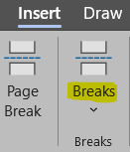
To insert a figure or table label, go to the References tab and select the option Insert Caption:
Select the option New Label:
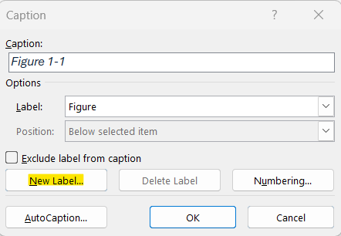

Create the new label with the indication of the Annex to which it belongs to – Figure A., Figure B., … or Table A., Table B, ...:
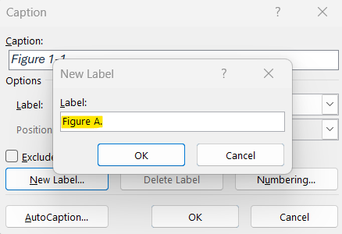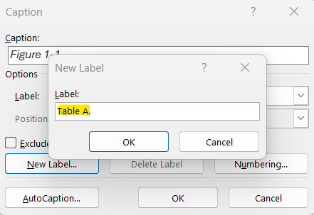

Introduction

Literature review

Sports Management and Technology in Sports

Technology as an Enabler

From Big Data to Analytics Integration

AI, ML & Blockchain Applications in Sports

Challenges & Opportunities

Related Work
<SLR – PRISMA – TDB >

3. Methodology
Following the definition of the research goal, it is essential to establish both the expected outcomes and the procedural behavior of the system. The analytical framework will operate continuously in the background, ingesting new data on a daily or weekly basis, securely storing it for longitudinal analysis, and computing key performance indices. The resulting AI-generated outputs are delivered through a centralized web platform, which provides stakeholders with structured reports, interactive visualizations, and automated alerts. To ensure that these outputs are both accurate and contextually relevant, tailored prompt engineering techniques are applied. This design choice enhances interpretability, enabling non-technical stakeholders to engage with complex findings in a clear and accessible manner.
In practical terms, the approach allows:
- Week-to-week risk monitoring using historical inputs with scalable logic
- Evidence-based off-season decision-making through data-driven projection
- Narrative reports that combine medical/physical stats with performance analytics
- Benchmarking against professional-level biometric data, which is rarely used in predictive models
- Reduced load on analytics department and more efficient procedures

Taking the above into consideration, this approach integrates three primary data sources:

- Historical player statistics – yearly data on performance and career development.
- Weekly performance data – focusing on the 2020 NFL season, capturing variables such as playing surface, consecutive game weeks, and weather conditions.
- Daily biometric monitoring – a full year of data from a former NFL player (Justin Hilliard), including heart rate, sleep patterns, fatigue, and subjective condition ratings.

These datasets support modeling for predicting probabilities for load management, injury likeliness, and performance optimization.

4. Empirical Study
Empirical study text Empirical study text Empirical study text Empirical study text Empirical study text Empirical study text Empirical study text Empirical study text Empirical study text Empirical study text Empirical study text Empirical study text Empirical study text Empirical study text Empirical study text Empirical study text Empirical study text Empirical study text Empirical study text

5. Results and Discussion
Text about results and discussion Text about results and discussion Text about results and discussion Text about results and discussion Text about results and discussion Text about results and discussion Text about results and discussion Text about results and discussion Text about results and discussion Text about results and discussion Text about results and discussion Text about results and discussion Text about results and discussion Text about results and discussion.

6. Conclusions and Future Research
Conclusion text Conclusion text Conclusion text Conclusion text Conclusion text Conclusion text Conclusion text Conclusion text Conclusion text Conclusion text Conclusion text Conclusion text Conclusion text Conclusion text Conclusion text Conclusion text Conclusion text Conclusion text.

Bibliographical References [This title should not be numbered]
Use APA Style for the entire document. Don’t forget to organize your bibliographical references alphabetically.
We suggest that students use a reference manager system (Zotero, Mendeley, EndNote).
Please review the APA style guide at: https://apastyle.apa.org/style-grammar-guidelines/references/examples
Example:
Author, A. A., Author, B. B., & Author, C. C. (Year). Title of article. Title of Periodical, volume number (issue number), pages. DOI or permanent link.

Appendix A (optional, appendixes should have letters instead of numbers)
[Appendixes are for materials, tables, or more explanation material only done by the student]
[It is mandatory to include in the appendixes the Ethics Committee Report when the research “[… involves human participants and personal data, regardless of whether it is collected online or in person, whether it is based on a survey, an experiment, a dataset, or interviews (i.e., it is also compulsory for observational studies and field interviews with managers)]”. You must get your report by answering a short questionnaire available here: https://novaims.eu.qualtrics.com/jfe/form/SV_eG085IyOwAj6a57

Annex A (optional)
[Annexes are optional, since they have material and sources not developed by the students, so in most cases referencing them is enough]


